User Guide

## Background:

LinkedIn is the world leader in the professional networking ecosystem. With our motto of “Connecting the world’s professionals to make them more productive and successful”, it is an utmost priority of LinkedIn to remain relevant for the new and old generation alike. However, our professional networking platform provides a well suited plethora of opportunities to experienced professionals but has a set back for recent college graduates.

So we asked ourselves, “How can LinkedIn make the platform more desirable for new graduates, who lack confidence, industry based skills and good mentors to guide them and help them follow their dream path ?” Bringing our best designers, engineers and PMs together, we brainstormed our way through to the problem to present before you our new product launch, “LinkedIn Freshers”.

LinkedIn Freshers will be solving the critical problem of upskilling and preparing new graduates with almost no corporate and industry experience with interview training modules so that they can land their dream jobs faster.

## Details:

The three major features are:

* **Job Recommendation** : Users can find suitable jobs/internships for them based on their career aspiration, goals and interests.

|  |
| --- |
| **Walkthrough Steps** |
| * Find recommended jobs based on profile and career aspiration which will also be directly sent to your mail. * Click on the Job search icon from the bottom navigation menu to find the list of recommended job * Bookmark and save the jobs which you want to apply later by clicking on the bookmark icon beside the job. |

*Job recommendations*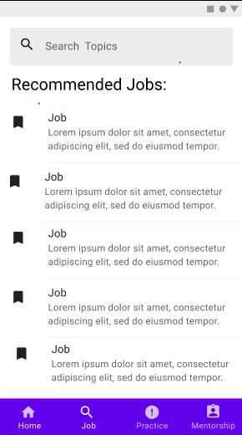

* **AI based mock interviewer** : Users can practice mock interviews with the AI service which records the sessions, evaluates user response and body language and outputs feedback with possible areas of improvement for the user.

|  |
| --- |
| **Walkthrough Steps** |
| * Click on the Practice tab on the bottom navigation menu to find the interview page * Search for specific topics or questions or choose from any of the recommended tags above * Select any of the questions that you want to answer and record interview video * Retake, delete, pause and replay the video before submitting * Wait for a few moments before receiving feedback and curated content for development * Go to the settings to customize the data privacy policies and interview mode to audio, video or chat only. |

*Interview service and feedback for users*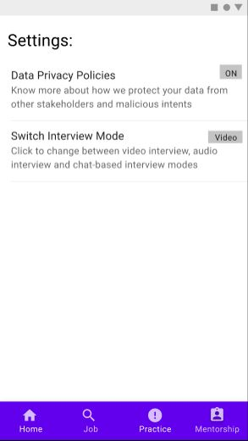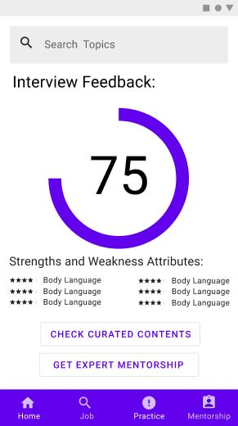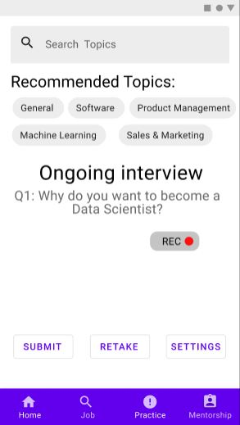

* **Expert mentors from academia and industry**: Users can find suggested experts in their areas of interests and request help from mentors, with whom they can set up a practice and review session via LinkedIn app itself to receive advice and areas of improvement. Further they can rate the service and provide feedback to get better recommendations later.

|  |
| --- |
| **Walkthrough Steps** |
| * Click on the Mentorship tab on the bottom navigation menu to find the list of recommended mentors * Search for specific areas or choose from any of the recommended tags above to find experts for those areas * Request mentorship from the mentors by clicking on Request Help button * On accepting a request, which is received by the mentor in his inbox, the mentor can initiate a conversation * The initiated conversation can be found in the users’ inbox which he can continue * The user and mentor can use linkedin messenger or linkedin video caller to have a conversation and discussion. * Users and mentors can rate the conversation, video quality and other factors for further engagement |

*Mentorship service and interaction platform* 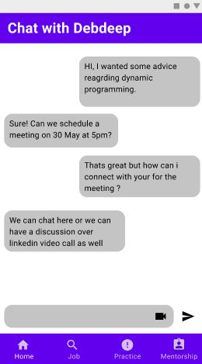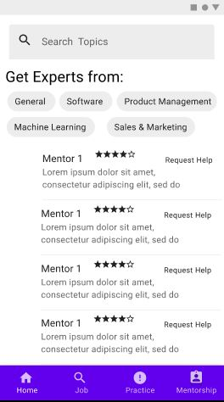

* Some of the issues and upcoming features are mentioned below:

|  |  |
| --- | --- |
| **Known Issues** | **Current Status** |
| Unavailable on older phones/other languages/other countries. | Currently available only in India in English for iOS6+ and Android Nougat+ users. Will be soon rolled out in other languages and other countries across the world. |
| Chatbot based interviewer unavailable. | Only video and audio based interviewer are available and chatbot based interview is expected to be rolled out soon, |
| Less Industry connects and interactivity. | More industry connects with leaders and employees and in the way , as we onboard more and more industries to our platform. |
| Topics related to medical are absent | More topics are in the pipeline and user feedback will be used to curate new content |